Multiple-choice section – choose the correct answer

Question 1 [7.1]

‘Three more than twice a number gives a solution of 22’ is:

A 2*n* + 3 = 22 B 3*n* + 2 = 22 C 2(*n* + 3) = 22 D 22 + 3 = 2*n*

Question 2 [7.1]

Use substitution to find the value of *a* in 2*a* − 5 = -11.

A *a* = 3 B *a* = -3 C *a* = 8 D *a* = -8

Question 3 [7.2]

Calculate the value of *x* in 13 − 2*x* = 5.

A *x* = 9 B *x* = -4 C *x* = -9 D *x* = 4

Question 4 [7.2]

What is the value of *y* where *x* = 2?

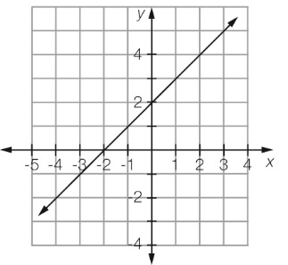

A *y* = 0 B *y* = 3 C *y* = 4 D *y* = 2

Question 5 [7.2]

From the graph in Question 4, what is the value of *x* where *y* = 0?

A *x* = 0 B *x* = -2 C *x* = 2 D *x* = 4

Question 6 [7.2]

To obtain *x* from  − 6 you would:

A add 6 and divide by 3 B subtract 6 and divide by 3

C add 6 and multiply by 3 D subtract 6 and divide by 3

Question 7 [7.4]

The solution of the balance diagram is:

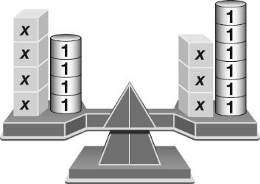

A *x* = 2 B *x* = -2 C 4*x* = 3*x* − 2 D *x* = 3

Question 8 [7.3]

Solve  + 5 = 2

A *b* = 28 B *b* =  C *b* =  D *b* = -12

Question 9 [7.3]

Solve 3(*x* − 6) = 21

A *x* = 1 B *x* = 13 C *x* = 5 D *x* = 9

Question 10 [7.4]

Solve 5*d* − 2 = 2*d* + 6

A *d* =  B *d* =  C *d* = 2 D *d* = 

Question 11 [7.4]

Solve *x* − 3 = 4*x* − 9

A *x* =  B *x* =  C *x* = 2 D *x* = -6

Question 12 [7.5]

Ella buys 4 chocolate bars and gets 60 cents change from $5.00. How much was each chocolate bar?

A $1.10 B $1.40 C $1.25 D $1.15

Multiple-choice results: ___ /12

Short answer section

Question 13 3 marks [7.3]

Here is David’s working to solve the equation  – 5 = 7. Unfortunately, David has made an error.

David’s working Correct working

 − 5 = 7

 = 12

*x* = 4

(a) Circle the line of working where the error appears.

(b) Write the correct working for the question in the space next to David’s working.

(c) Briefly explain where David went wrong in the calculation.

Question 14 3 marks [7.2]

This graph describes the costs to hire a taxi.

Using specific examples from the graph, write a sentence to describe how a taxi fare is charged.

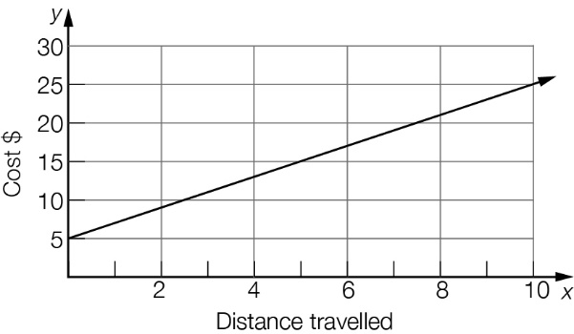

Question 15 4 marks [7.1]

Write an equation for each of the following.

(a) Twice a number plus four gives a result of twenty-two.

(b) The sum of a number and five is three less than twice the number.

Question 16 6 marks [7.1]

Check by substitution whether the number in the brackets is a solution for the equation.

(a) 3*x* − 5 = 13 (*x* = 6) (b)  = 20 (*x* = 4) (c)  = -1 (*x* = -1)

Question 17 2 marks [7.1]

Write a sentence that fits the equation using only words.

2(*m* − 2) = 10

Question 18 4 marks [7.1]

Write an equation for each of these rules, using the given pronumerals for each of the   
quantities described.

(a) Force (*F*) is equal to mass (*M*) multiplied by acceleration (*a*).

(b) The number of red marbles (*R*) in a bag is five less than twice the number of blue marbles (*B*).

Question 19 2 marks [7.2]

Use the diagram to calculate the value of *x*.

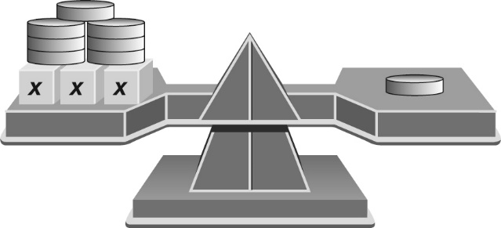

Question 20 4 marks [7.2]

Solve each of these linear equations using algebra.

(a) 3*c* + 5 = 4 (b) 17 + 4*b* = -33

Question 21 4 marks [7.2]

Use the following graph to find the value of:

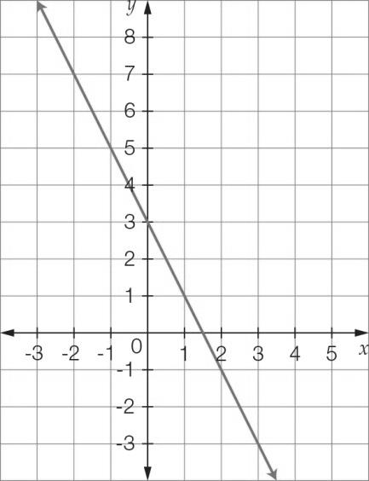

(a) *y* where *x* = 2 (b) *y* where *x* = -2



(c) *x* where *y* = 3 (d) *x* where *y* = 0

Question 22 4 marks [7.2]

Solve each of these linear equations using algebra.

(a) 3*a* − 5 = -17 (b) 23 + 4*b* = 5

Question 23 4 marks [7.2]

Solve each of these linear equations using algebra.

(a) 2*x* − 5.6 = 7.2 (b)  + 3*x* = 

Question 24 4 marks [7.2]

Solve each of these linear equations using algebra.

(a) 5 − 4*x* = -15 (b) -3 − 2*m* = 9

Question 25 3 marks [7.2]

Jason buys a cup of coffee each week day morning. On two mornings he also buys a sandwich for $4.50. He spends a total of $26.50 for food and drink over the five mornings. Use an equation to find the cost of a cup of coffee.

Question 26 6 marks [7.3]

Solve the following equations involving fractions.

(a)  = 7 (b)  + 8 = 5

Question 27 9 marks [7.3]

Solve each of the following equations.

(a) 3(*x* − 5) = 21 (b) 4(3*x* + 2) = 24 (c) 5(2*c* − 3) = 22

Question 28 6 marks [7.3]

Write the following statements as equations and then find the value of the unknown.

(a) A number is doubled and then has six subtracted from it. The result is eight. What is the number?

(b) Three is subtracted from a number and the result is tripled. If the total of this is eighteen, what is the number?

Question 29 4 marks [7.3]

A farmer has 420 m of electric fence to fence an area for the horses. The fenced area will be in the shape of a rectangle and be twice as long as it is wide. Write an equation for this information and then use the equation to find out the dimensions of the fenced area.

Question 30 3 marks [7.4]

Use the diagram to calculate the value of *x*.

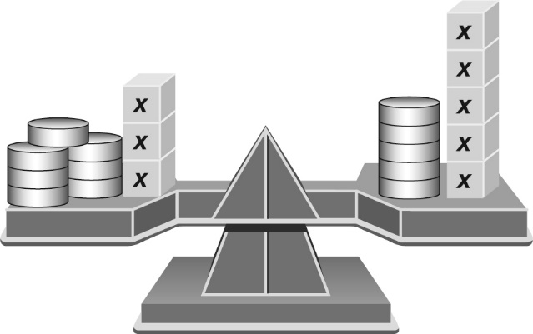

Question 31 9 marks [7.4]

Solve the following equations using algebra.

(a) 5*x* − 4 = 2*x* + 5 (b) 3*x* + 4 = 8*x* − 11 (c) 2*x* + 5 = 7*x* − 6

Question 32 6 marks [7.4]

Solve the following equations using algebra.

(a) 3*x* − 6 = 2(*x* + 5) (b) 6(*x* + 2) = 2(1 − 2*x*)

Question 33 9 marks [7.4]

Solve the following equations using algebra.

(a)  =  (b) =  (c) 2*x* + 4 − 5 = 3*x* + 1

Question 34 6 marks [7.4]

Solve the following equations graphically by finding the point of intersection of relevant graphs.

(a) 2 − *x* = *x*

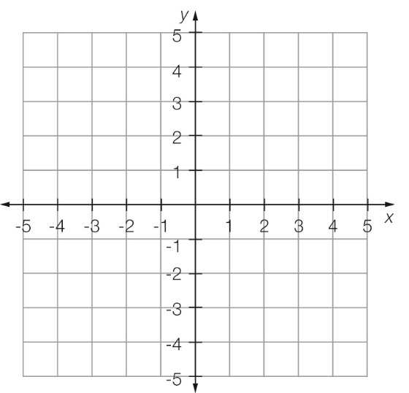

(b) 3*x* + 5 = 1 − *x*

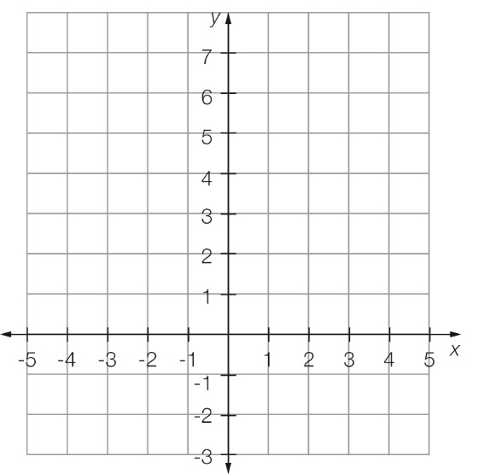

Short answer results: ___ / 105

Extended answer section

Question 35 9 marks [7.2, 7.3, 7.5]

A 5 L bucket is filled to the top. It has a leak so that 500 mL of water leaks out every minute. The rate of leakage is shown in the graph.

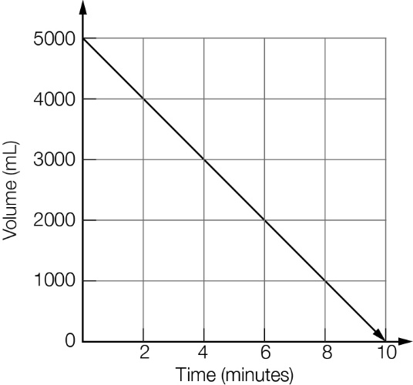

(a) How much time does it take for the bucket to empty?

(b) Give the graph a title.

(c) What does the point (0, 5000) represent?

(d) How much time has passed when there is 3500 mL left in the bucket?

(e) How much water is left in the bucket after 4 minutes?

(f) How much water is left after 7 minutes?

(g) How much water has leaked from the bucket after 8 minutes?

(h) Which is the correct equation for the graph?

A *t* = 500 − 5000*V* B *t* = 5000 − 500*V* C *V* = 500 − 5000*t* D *V* = 5000 − 500*t*

(i) If the rate that the water leaked from the bucket doubled, how long would it take for the bucket to be empty?

Question 36 6 marks [7.1, 7.2, 7.5]

Peta has a mobile phone plan that provides $350 of SMS and calls each month. Each month it costs $35 plus the cost of any additional SMS and calls over the $350 covered by the plan.

SMS cost 22 cents each and each call costs $0.50 plus 12 cents per 10 seconds.

(a) Write an equation for the cost of a call $*C* that is *n* minutes long. (Note that she is charged by the 10-second interval.)

(b) What is the cost of a call that is 11 minutes long?

(c) What is the cost of 5 calls with a total time of 50 minutes?

(d) One month Peta has calls with a total cost of $213 and sends a total of 793 texts. What is her bill for this month?

Question 37 9 marks [7.1, 7.2, 7.5]

Jarod is 10 years older than Kerry and 20 years younger than Cassandra.

(a) Write an expression linking Jarod’s age (*J*) and Kerry’s age (*K*).

(b) Write an expression linking Jarod’s age (*J*) and Cassandra’s age (*C*).

(c) Using the above two expressions, write an equation that links just Kerry’s age (*K*) and Cassandra’s age (*C*).

(d) Using algebra, make Cassandra’s age (*C*) the subject of the equation.

(e) Cassandra is five years older than twice Kerry’s age. Make another algebraic statement linking Cassandra and Kerry’s ages.

(f) Graph the equations for Cassandra and Kerry from parts (d) and (e) on the axes below then state Kerry and Cassandra’s ages.

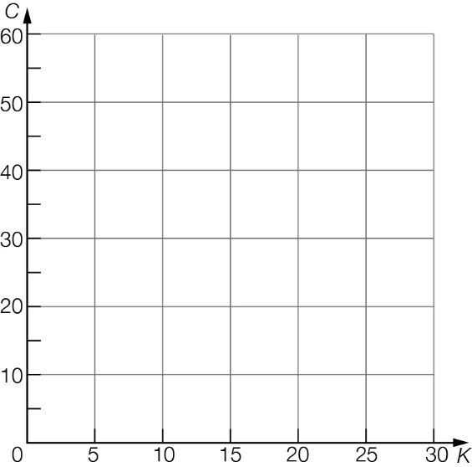

(g) What is Jarod’s age?

Extended answer results: ___ / 24

TOTAL test results: ___ / 141